**Steps of TCP_Control:**

**Note :Please use a laptop to carry out the experiment.**

1.First, you need to remotely transfer the TCP_Control_Route.c we provide to the Raspberry Pi image system via SSH.

The transfer steps are as follows:

1. Click on the location shown below to get the SSH transfer tool.

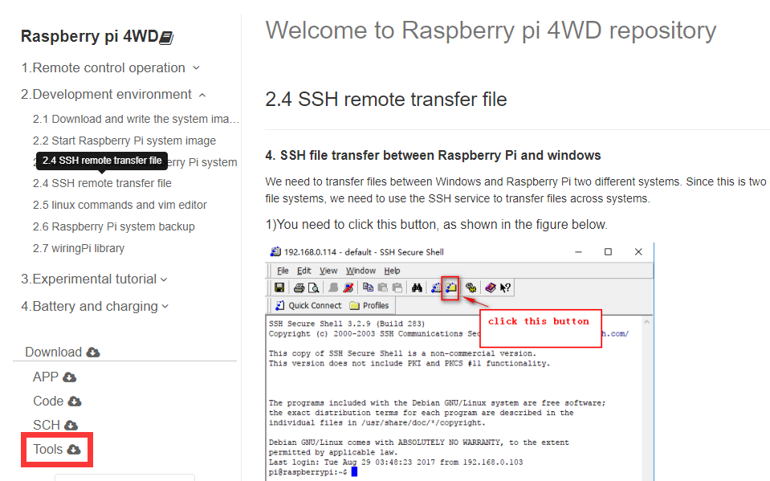

2.Click on the location shown below to log in to the Raspberry Pi system.

(The IP address is 192.168.0.1 and the password is yahboom.)

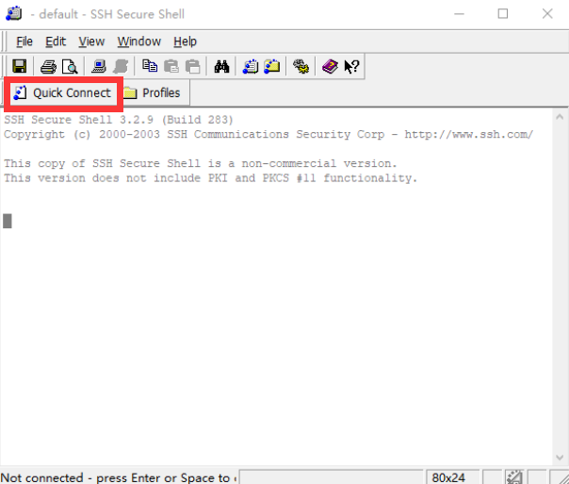

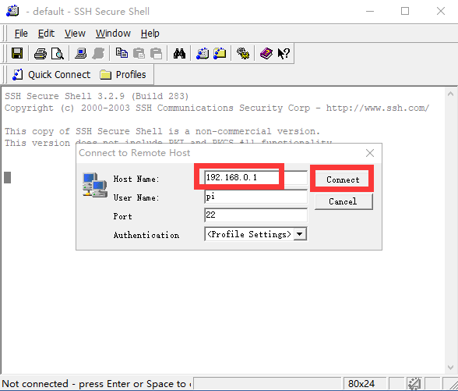

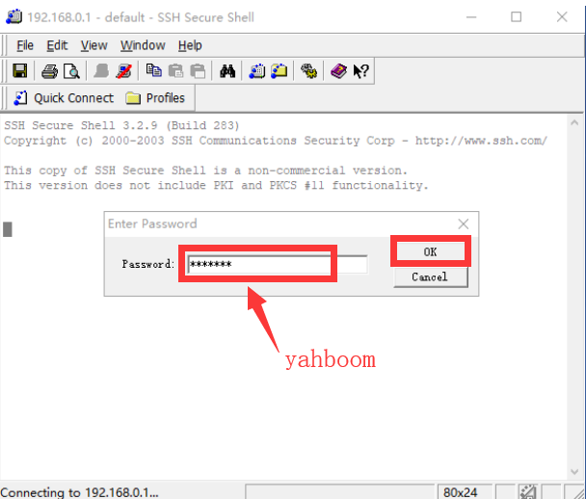

3. We need to drag the TCP_Control_Route.c file to the right Raspberry Pi system.

4. After the drag and drop is completed, as shown in the figure below, we can see TCP_Control_Route.c in the Raspberry Pi system on the right.

After the above steps, we have successfully transferred the TCP_Controll_Route.c file to the Raspberry Pi image.

5.You need to remotely log in to the Raspberry Pi system via putty, as shown below: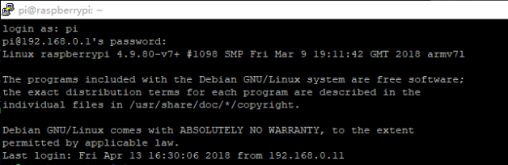

1. Switch the root user.

You need to enter the command: **su**

Then enter the password yahboom

(the password here is hidden and can't be seen, please be careful not to enter the error!)

At this point we successfully entered the root privileges, as shown below:

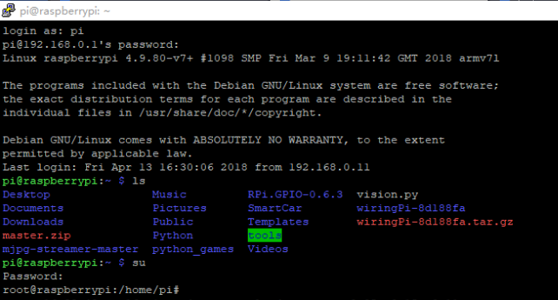

7.You need to enter the command: top

This command is to view the process ID of all processes in the Raspberry Pi system.

As shown in the figure below, we can see that the 519 process number is a Bluetooth remote process, you need to remember this number.

(Note! Different Raspberry Pi process numbers are different. Please refer to the process shown in your own system)

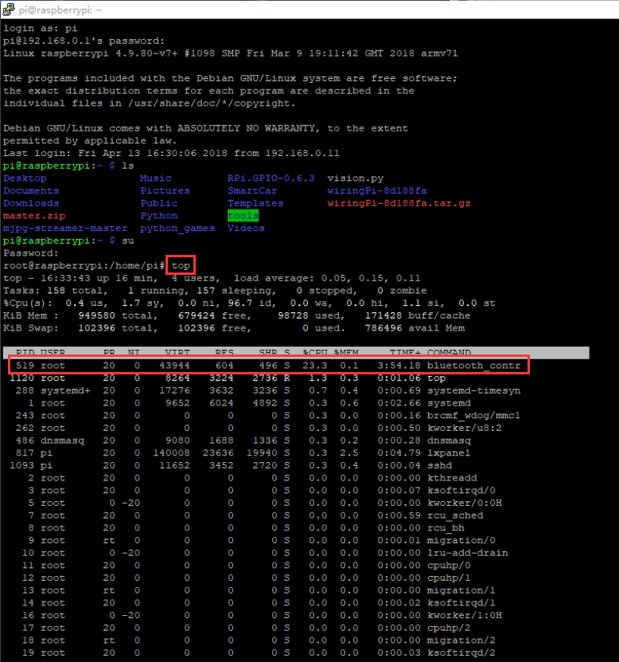

8.After obtaining the Bluetooth process number, press ctrl+z on the keyboard to exit this interface.

9.We must kill the Bluetooth process in order to avoid conflicts between the TCP process and the Bluetooth process.

Enter the command: kill -9 519

As shown below:

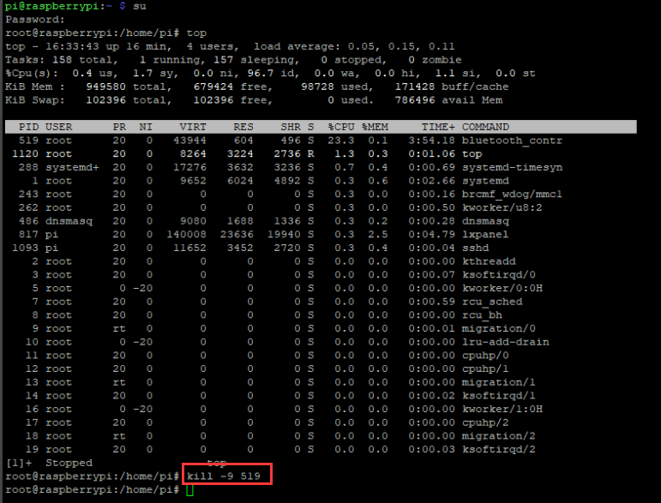

1. We need to go to the SmartCar directory:

Enter command: cd SmartCar

   ls

We can see the TCP_Controll_Route.c file inside.

As shown below:

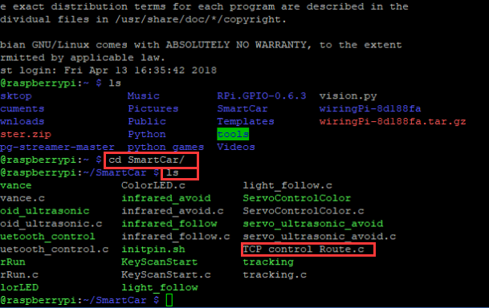

11.Enter the command:

gcc TCP_Control_Route.c -o TCP_Control_Route -lwiringPi -lpthread

This command is to compile TCP_Control_Route.c generates the executable file TCP_Control_Route, which is correct as long as no error is reported during compilation, as shown in the following figure.

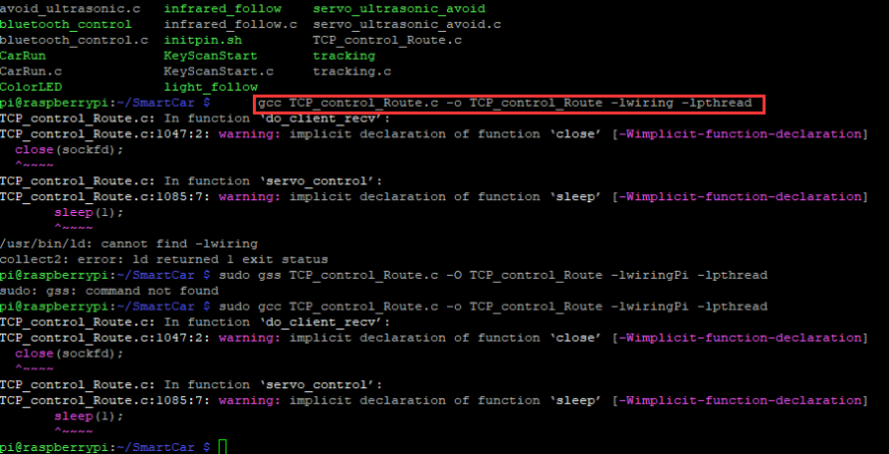

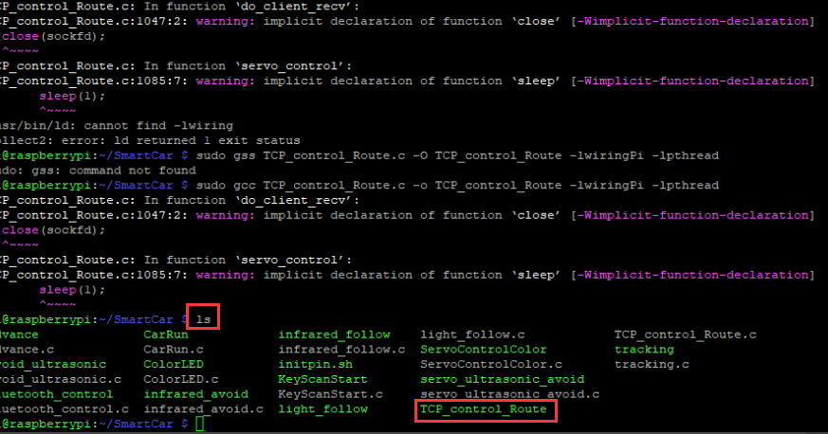

12.Enter the command:

./TCP_control_Route

This command is to run the executable.

The prompt Listen.... will appear as shown below.

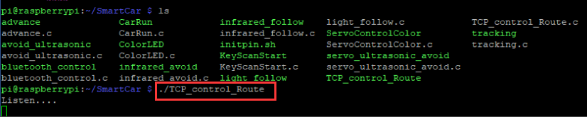

13.We need to open the host computer software to choose BST_4WD_Raspberry Pi.

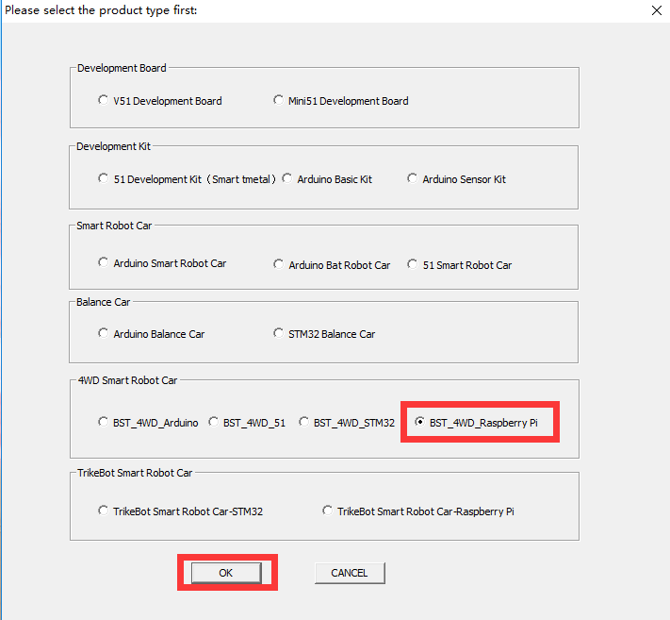

1. Click **[Connect Video]** to see the video picture captured by the camera.

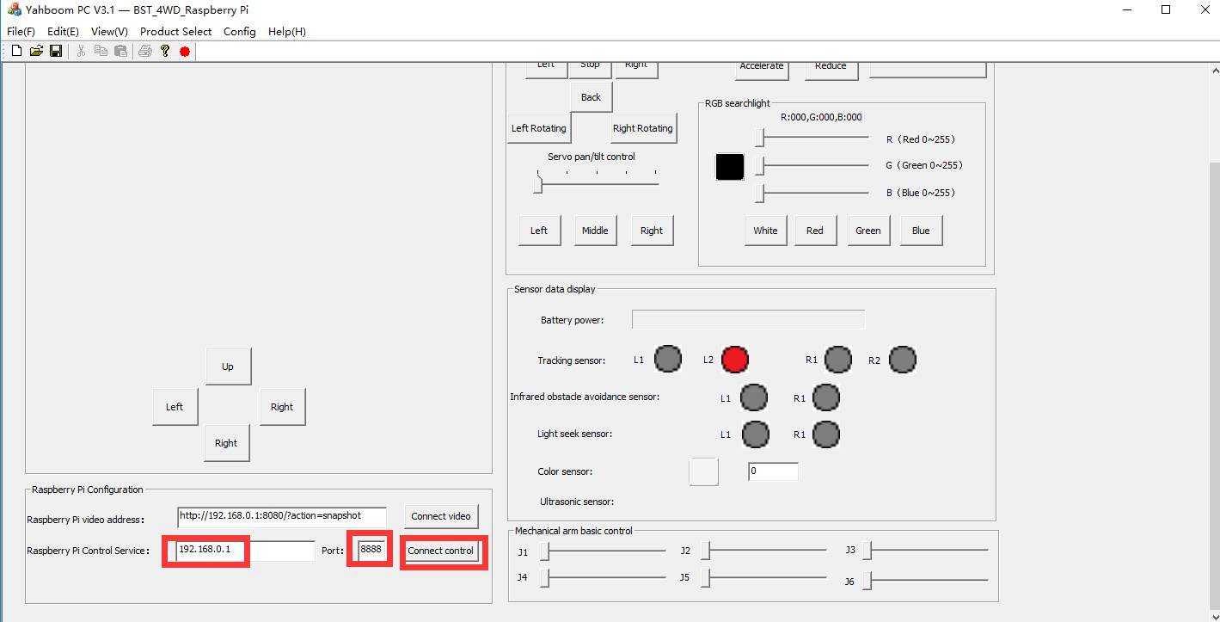

1. Click **[Connect Video]**  again to close the video picture captured by the camera.
2. Click **[Connect control]** to enter remote control car mode.

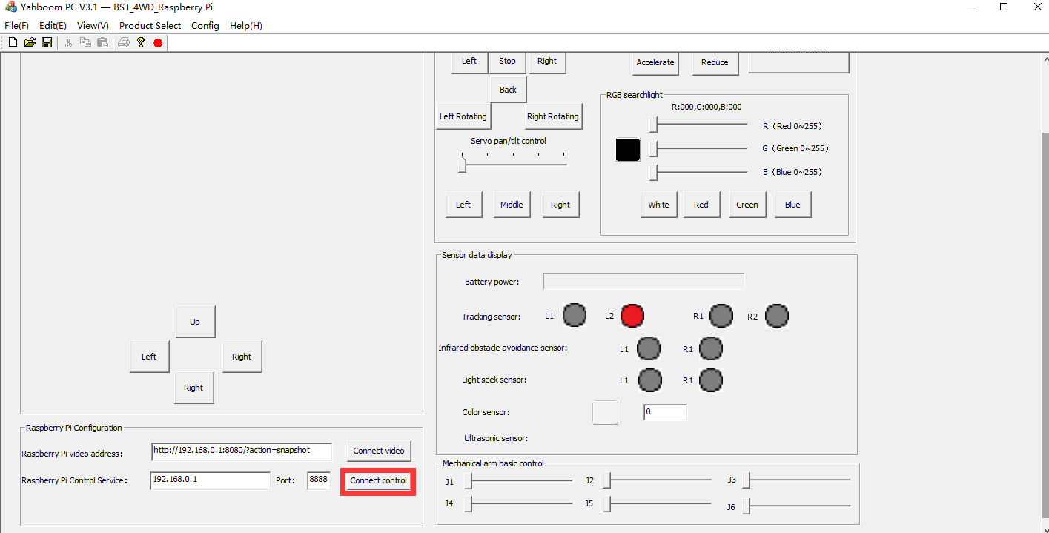

1. You can control the car in the area on the right.

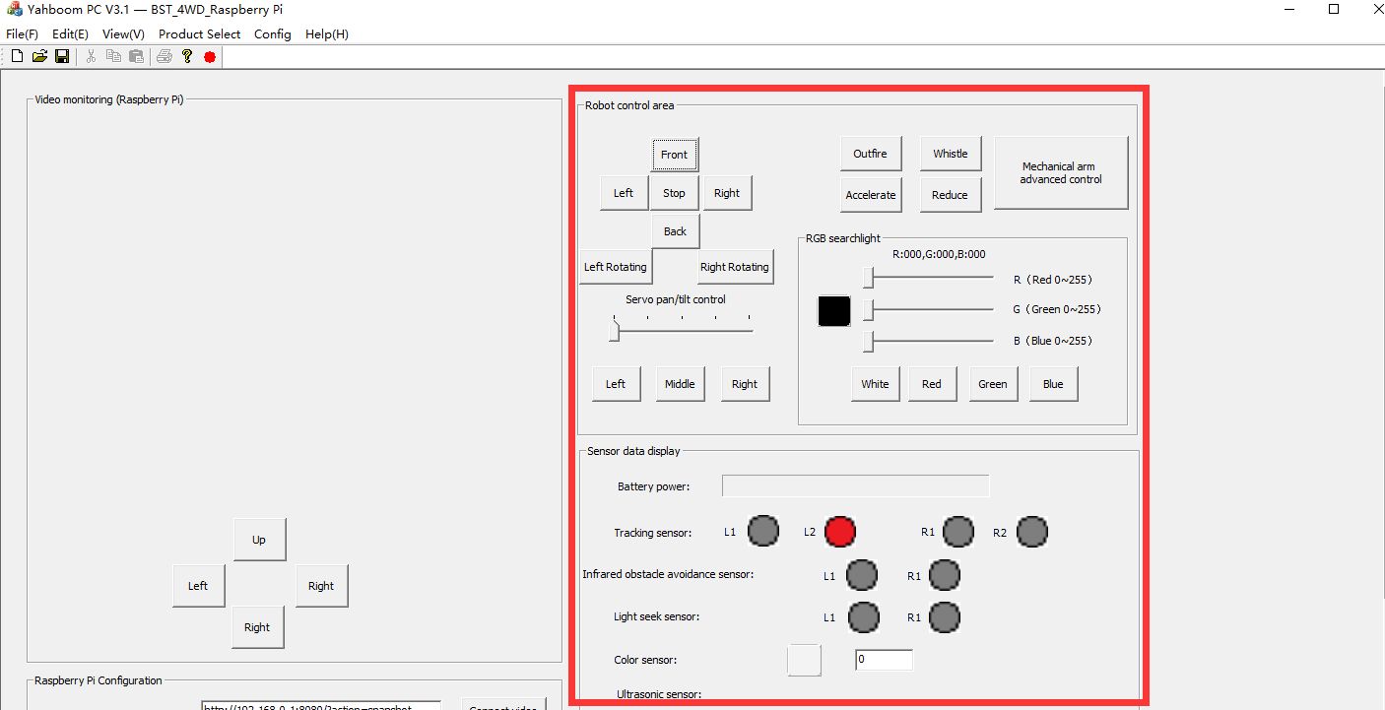

At the same time, the Raspberry Pi system will have the following tips:

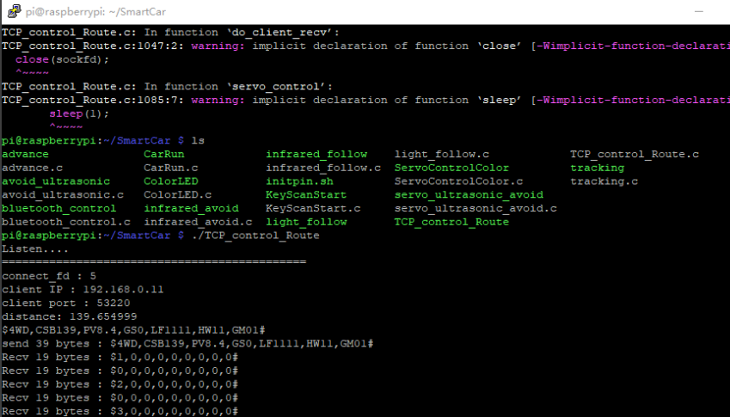

Note: If you want to configure the port and ip address in the code file.You can modify the code as shown below.

